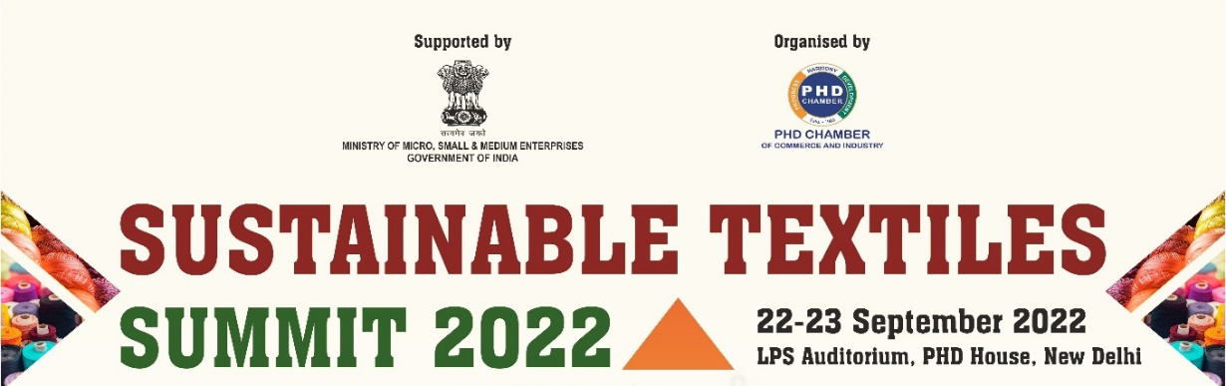

**KNOWLEDGE PARTNER**

**Department of Textile and Fibre Engineering, Indian Institute of Technology, Delhi**

**Programme - Day-1: 22 September 2022**

|  |  |  |
| --- | --- | --- |
| 1100 Hr | Registration & networking tea | |
| 1130 – 1315 Hrs  **Theme: Sustainable and Circular Textiles**   * Building Sustainability and circularity in the textile value chain * Policy reforms, Strategy for Textiles sustainability * Environmental Issues | | |
| 1130 Hr | Welcome Address | **Mr Madhu Sudhan Bhageria**, Chair, PHDCCI Textiles Committee & CMD, Filatex India Ltd. |
| 1140 Hr | Presidential Address | **Mr Pradeep Multani**, President, PHDCCI & Chairman-Emeritus, Multani Pharmaceuticals Ltd. |
| 1150 Hr | Theme Address | **Prof R. S. Rengasamy**, Head, Department of Textile and Fibre Engineering, Indian Institute of Technology, Delhi |
| 1205 Hr | Special Address-1 on Global perspective on sustainable and circular textiles | **Mr Vincent Duret**, Responsible Business Unit Textile, Textile Business Unit Manager, Ecocert Greenlife SAS, France |
| 1220 Hr | Special Address-2 on Environmental issues | **Mr Atul Bagai,** Country Head, United Nations Environment Programme (UNEP) |
| 1240 Hr | Chief Guest Address | **Mr Upendra Prasad Singh,** Secretary, Ministry of Textiles, Govt. of India |
| 1310 Hr | Vote of Thanks | **Mr Ramesh Menon,** Co-Chair, PHDCCI Textiles Committee & MD, Damodar Menon International Pvt Ltd. |
| 1315 – 1415 Hrs – Networking Lunch Break | | |



**KNOWLEDGE PARTNER**

**Department of Textile and Fibre Engineering, Indian Institute of Technology, Delhi**

**Programme - Day-1: 22 September 2022**

|  |  |  |
| --- | --- | --- |
| 1415 Hrs – 1530 Hrs  **Session – 1, Theme: Recycling Textiles**  Panel Discussion:   * Reduce Textile Waste in Landfill * Increase recycling and reuse * Post-industry textile waste * Post-consumer textile waste * Source Fabric from Pre-used Textile Products * Recycling Technologies * Global best practices in recycling textiles | | |
| 1415 Hr | Special Address-1 | **Mr Sudhir Kumar,** Adviser, Niti Aayog, Govt. of India |
| 1425 Hr | Special Address-2 on Building an inclusive & circular textile waste value chain in India | **Mr Partha Talukder**, Venture Builder & Investment Manager, Enviu, Netherlands |
| 1440 Hr | Setting up of Theme by Moderator | **Prof B. K. Behera**, Department of Textile and Fibre Engineering, Indian Institute of Technology, Delhi |
| Panelists | **Mr Partha Talukder**, Venture Builder & Investment Manager, Enviu, Netherlands |
| **Mr B M Sharma,** Jt. Managing Director, RSWM Limited |
| **Mr Debabrata Ghosh**, Vice President & Sales Director, Oerlikon Textile India Private Limited  **Mr Sudipto Mandal,** Manager - Sales & Marketing, Oerlikon Textile India Private Limited |
| **Prof Prabir Jana**, Department of Fashion Technology, NIFT Delhi |
| **Mr Amit Saha**, Founder & CEO, Pro India Solutions |
| 1520 Hr | Q & A, and Summing up by the moderator | **Prof B. K. Behera**, Department of Textile and Fibre Engineering, Indian Institute of Technology, Delhi |
| 1530 Hr | Vote of Thanks | **PHDCCI** |
| 1530 – 1600 Hrs – Networking Tea Break | | |



**KNOWLEDGE PARTNER**

**Department of Textile and Fibre Engineering, Indian Institute of Technology, Delhi**

**Programme - Day-1: 22 September 2022**

|  |  |  |
| --- | --- | --- |
| 1600 – 1730 Hrs  **Session-2, Theme: Role of Brands in Textiles Sustainability**   * Opportunities & Challenges in sustainable textiles * Role of govt. in promoting sustainability * Sharing economy * Circular Product Design & Sustainability * Global Brands – best practices in sustainability | | |
| 1600 Hr | Special Address-1 | **Mr Vijoy Kumar Singh, IAS,** Special Secretary, Ministry of Textiles, Govt. of India |
| 1615 Hr | Special Address-2 on International perspective for policy, and sustainability in textile value chains | **Ms Lindita Xhaferi-Salihu,** Sectors Engagement Lead, United Nations Framework Convention on Climate Change (UNFCCC)  (Virtual) |
| 1630 Hr | Setting up of Theme by Moderator | **Mr Ujjwal Narayan**, Assistant News Editor, NewsRise |
| Panelists | **Prof Abhijit Majumdar**, Institute Chair, Department of Textile and Fibre Engineering, Indian Institute of Technology, Delhi |
| **Mr Girish C. Desai,** Head - Product Stewardship, Polyester Sector, Reliance Industries Ltd. |
| **Engr Md Shafiqur Rahman,** President, ITET (The Institution of Textile Engineers and Technologists), & Managing Director, Hams Group, Bangladesh |
| **Mr Rohan Batra**, Textile & Retail Sustainability, Marks & Spencer |
| 1715 Hr | Q & A, and Summing up | **Prof Abhijit Majumdar**, Institute Chair, Department of Textile and Fibre Engineering, Indian Institute of Technology, Delhi |
| 1730 Hr | Vote of Thanks | **PHDCCI** |



**KNOWLEDGE PARTNER**

**Department of Textile and Fibre Engineering, Indian Institute of Technology, Delhi**

**Programme - Day-2: 23 September 2022**

|  |  |  |  |  |
| --- | --- | --- | --- | --- |
| 1130 – 1315 Hrs  **Session-3, Theme: Digital Manufacturing, Industry 4 & sustainability**   * Automation and smart manufacturing * Sustainable Fibres * Industry 4.0 – Digital Manufacturing * Supply chain visibility * Supply chain resilience | | | | |
| 1130Hr | | Special Address | | **Smt Prajakta L Verma,** Joint Secretary, Ministry of Textiles, Govt. of India |
| 1140 Hr | | Setting up of Theme by Moderator | | **Prof B. S. Butola**, Department of Textile and Fibre Engineering, Indian Institute of Technology, Delhi |
| Panelists | | **Mr Vincent Duret**, Responsible Business Unit Textile, Textile Business Unit Manager, Ecocert Greenlife SAS, France |
| **Dr Rudrajeet Pal,** Professor, Textile Value Chain, Swedish School of Textiles, University of Borås, Sweden (virtual) |
| **Dr Sunil Jha**, Professor, Department of Mechanical Engineering, IIT Delhi |
| **Mr Sanjeev Sinha,** Sustainability Head, Fibers Segment, Thailand |
| **Mr Rajendra Singh,** Dy Director, Trade and Export Promotion Centre, Nepal |
| 1300 Hr | Q & A, and Summing up by the moderator | | **Prof B. S. Butola**, Department of Textile and Fibre Engineering, Indian Institute of Technology, Delhi | |
| 1310 Hr | Vote of Thanks | | **PHDCCI** | |
| 1315 – 1415 Hrs – Networking Lunch Break | | | | |