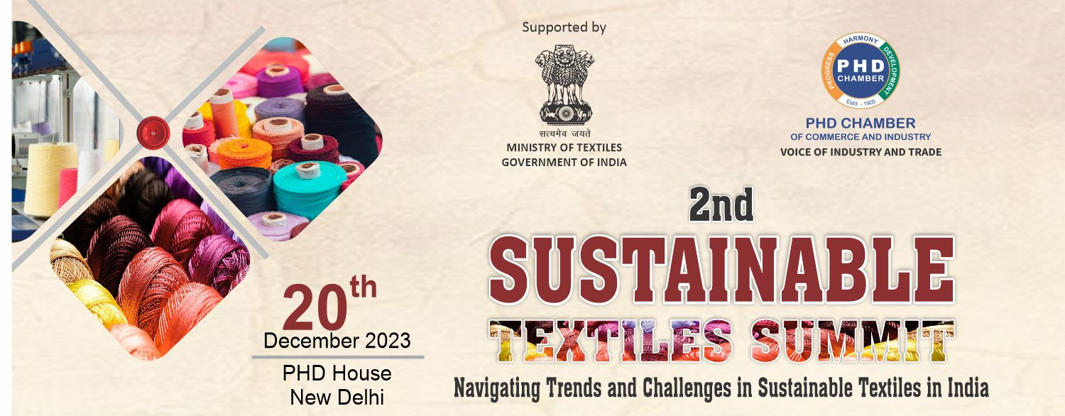


Program Agenda

09:30 AM - 10:00 AM | Registration and networking welcome Tea/Coffee
10:00 AM – 10:05 AM | Opening remarks by Mr. Naveen Seth, DSG, PHDCCI
10:00 AM - 10:10 AM | Overview, Introduction to the summit's theme and objectives by Mr Madhu Sudhan Bhageria, Chair, PHDCCI Textiles Committee & CMD, Filatex India Ltd.
10:10 AM - 11:25 AM
Inaugural Session - Policies and Regulations, Challenges & Opportunities for Textile Sustainability, and Way forward
10:10 AM - 10:20 AM | Challenges & Opportunities for Navigating Compliance and Best Practices in textile sustainability, Mr. Anil Jadhav, Regional Director, South Asia & Middle East, Ecocert
10:20 AM - 10:30 AM | Roadmap for Achieving Sustainable Targets, Dr. (Prof.) Abhijit Majumdar, Institute Chair, Department of Textile and Fibre Engineering, Indian Institute of Technology, Delhi
10:30 AM – 10.40 AM | Emerging Textile Technologies for Sustainability Considering Polymer Processing, Manmade Fibre and Recycling by Mr. Debabrata Ghosh, Vice President & Sales Director, Oerlikon Textile India Private Limited
10:40 AM – 10.50 AM | Creating Green & Fair Value Chain from Farm to Fashion by  Mr. Abhishek Jani, CEO, Fairtrade India
10:50 AM - 11:00 AM | Sustainable Lifecycle Stages of a Textile Production Process: India Case Study by Dr Srikanta K Panigrahi, Director General, Indian Institute of Sustainable Development (IISD) & Former Secretary, Govt. of India
11:00 AM – 11:10 AM | Existing and Upcoming Textile Sustainability Regulations in India by Smt. Prajakta L Verma, Joint Secretary, Ministry of Textiles, Govt. of India
11:10 AM – 11.20 AM | Q&A
11:20 AM – 11:25 AM | Vote of Thanks by Mr. R K Vij, Co-Chair, PHDCCI Textile Committee & Secretary General, PTA Users Association
11:25 AM - 11:45 AM | Tea/Coffee Break
11:45 AM - 1:05 PM
Session 1 - Mapping the Landscape of Sustainable Textiles in India
11:45 AM - 11:55 AM | Exploring the Intersection of Environmental and Economic Sustainability in Textile Recycling by Prof. Bipin Kumar, Department of Textile and Fibre Engineering, Indian Institute of Technology, Delhi
11:55 AM – 12.05 PM | Challenges & Opportunities for Navigating Compliance and Best Practices in textile sustainability, Ms Manisha Choudhary, National Coordinator, Partnership for Action on Green Economy (PAGE) India, UN Environment Programme India Office
12:05 PM - 12:15 PM | Supply Chain Sustainability and Ethical Practices by Mr. Anupam Prasad, Head of Office-India, Sedex
12:15 PM – 12:25 PM | Building Industry for a Future Led by Innovation & Sustainability | Sustainable Recycling Machinery & Technology Solutions for MMF Industry by Mr. Sudipto Mandal, Manager - Sales & Marketing, Oerlikon Polymer Processing Solutions Division, Manmade Fibers Solutions Unit, Oerlikon Textile India Pvt. Ltd.
12:25 PM – 12:35 PM | Building social impact ventures for an inclusive and circular textile waste value chain in India by Ms. Greeshma Hegde, Regional Program Manager, Enviu
12:35 PM – 12:45 PM | The Current State of Sustainable Textiles, Recycling Technologies in India, Mr. Gagan Kansal, Director, Kay Gee Enterprises
12:45 PM – 12:55 PM | Q&A
12:55 PM – 01:05 PM | Vote of thanks by Mr. C R Rai, Co-Chair, PHDCCI Textile Committee & C&R Textiles Pvt. Ltd.
01:05 PM – 02:15 PM | Networking Lunch Break
02:15 PM - 3:55 PM
Session 2 – Textile Sustainability, Textile Recycling, Challenges & Opportunities,
and
Panel Discussion on Carbon Disclosures and Emissions Reduction
02:15 PM – 02:25 PM | Special Address  Textile Recycling: The Challenging World Landscape, Dr. Prabir Jana, Professor, Department of Fashion Technology, Shahi Chair Professor, Industry 4.0, NIFT
02:25 PM – 02:35 PM | Special Address  Changing global compliance and opportunities in India: Showcasing how collective efforts can change the landscape by Mr. Kamlesh Pal, Program Officer-Alternate Material, IDH-The Sustainable Trade Initiative
02:35 PM – 02:45 PM | Special Address  Chemical Management Systems using ZDHC guidelines and solutions for Textile Industry by Mr. Saket Kulkarni, Implementation Manager-South Asia, ZDHC
02:45 PM – 02:55 PM | Presentation on Insight on the textile sector disclosure and a way forward by CDP Operations India Private Limited by:  - Ms. Bhanvi Sharma, Manager-Supply Chain  - Mr. Faham Khan - Senior Disclosure Engagement Officer
Panel Discussion:
Reducing Carbon Emissions in the Textile industry in India
02:55 PM – 03:40 PM | Moderation by Ms. Shweta Basu, Manager-Corporate Engagements & Partnership  Panellists:  - Mr. Jaswant Singh, Sr. Manager – Sustainability Operations, EKI Energy Services Ltd.  - Mr. Abhishek Bansal, Head – Sustainability, Arvind Ltd.  - Dr. Siva Pariti, Ph. D., (Tech), (C.Col., A.S.D.C.), Member of the Trustee Board, Society of Dyers and Colourists (SDC) United Kingdom, Senior Technical Marketing Officer, BluWin Limited  - Mr. Surya Prakash Valluri, CSO, Grasim Ltd.
03:40 PM – 03:50 PM | Q&A
03:50 PM – 03:55 PM | Vote of Thanks by Mr. Rakesh Kumar Sangrai, Director, PHDCCI
03:55 PM | Tea/Coffee and Networking

* * *

